APPENDIX-A

# Internship Proposal Form

1. Name of the student: Divya Gidwani
2. Name of the organization (attach company Profile): Kanerika Software Pvt Ltd
3. Turnover of the company (for private companies):
4. Duration for which allowed: 20/01/2025 to 19/07/2025
5. Paid/unpaid: Paid If paid, then monthly stipend: 20,000



1. Assigned Department/ Division/ Unit: KLabs
2. Name & Designation of Project Mentor: Kothakonda Sarika
3. Brief work profile of student during internship

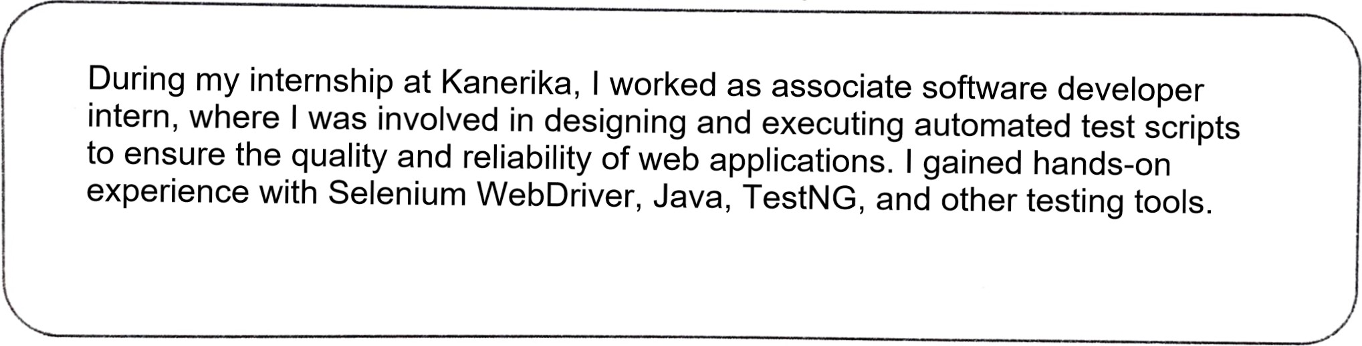

1. Work targets/objectives to be achieved during internship

|  |
| --- |
| Understand the Project Architecture: Gain a clear understanding of the application under test, its modules, and workflows.  Learn and Set Up Automation Tools: Get hands-on experience with tools like Selenium WebDriver, TestNG, Maven, and Git. Set up the test automation framework locally and run test suites successfully.  Create and Maintain Automation Scripts: Develop reusable and maintainable test scripts for regression and functional testing. Automate critical test scenarios with validations and assertions. |

It will be ensured that the attendance record of the student would be maintained and be submitted to the University at the end of internship duration.

Signature of Project mentor with seal